**Federal Contract # DTFH61-17D00001 – Task Order #2**

**LONG-TERM BRIDGE PERFORMANCE PROGRAM**

PROGRESS REPORT NO. 5

Report Period: February 1, 2018 – February 28, 2018

Prepared For:

**Federal Highway Administration**

Prepared By:

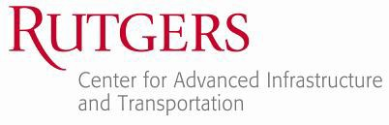

**A. Account of work performed in this period**

* 1. **Coordination and Meetings Between the Contractor and FHWA LTBP Team**

The Rutgers team attended a meeting at FHWA Turner Fairbank on 2/23 to provide a through update about all tasks related to task order 1 and task order 2 of the LTBP TSSC contract. The Rutgers team provided the minutes of the meetings on 3/2.

Co-PI: 26 hours

Project Support: 1 hour

* 1. **Develop LTBP Program bridge performance strategic research matrix**

In February 2018 work began on the visualization concept development for the Strategic Research Matrices (Task 2.2.4). Work was continued on development of the automated literature meta-data collection routines for use in Phase II (Task 2.2.3). Further, work was continued on investigating available sources of data for funding information (Task 2.2.3). The scope of work was modified in this time to better align with FHWA priorities as communicated in the February meeting at Turner-Fairbank. More details about each task can be found later in this section.

Task 2.2.3 - Development of Review Protocol: After the meeting with FHWA, the focus of work was shifted towards the collection and dissemination of meta-data concerning recent, current, and planned research, as opposed to a more comprehensive and qualitative survey of fundamental research. This shift in focus requires modification to the review protocols. It was decided that the body of research to be investigated would include research only from the following sources: a) NCHRP, b) Pooled-Fund Studies, c) single State DOT-funded research, and d) FHWA. This excludes research funded by NSF, NIST, and other parties. Because of this shift in focus, work was performed to create a software tool to “scrape” information from the Transportation Research Board website. The TRB website contains a repository of research that includes research funded by the four entities listed above.

Task 2.2.3 - Development of Review Protocol: Work was begun on investigating resources for supplementary research funding information. Early work with the TRB research repository showed that most literature is missing funding information for State DOT and Pooled-Fund research. Work is continuing on searching for State-owned repositories of research that include research funding information.

Task 2.2.4 - Development of Initial Visualization Concepts: An initial survey of visualization concepts was begun. It is the intention of the research team to create a basic visualization package to match that created for the Long-Term Pavement Performance program, called the “Tablecloth.” (See Appendix A).

Co-PI: 4.5 hours

Project Engineer: 150 hours

Staff Engineer: 80 hours

Project Support: 6 hours

* 1. **Conduct training for all field personnel on LTBP Protocols**

No work was performed for this task.

* 1. **Development of data collection protocols and RABIT-CE operations manual**

Task 4.2.1. Instrumentation Protocols - After initial submission of the drafts on January 25th, the Rutgers team did a complete review to assure the consistency of developed protocols. Several issues were found and a comprehensive review letter was submitted to the Pennoni (see Appendix B). The outlines of the comments were also discussed with the Pennoni group via a conference call. A synopsis of the problematic issues was also presented to the COR team at the February 23rd meeting at the FHWA-TFHRC office. While Pennoni was resolving the issues, the Rutgers team continued working on important protocols (mainly instrumentation design protocols).

Task 4.2.2. Legacy Data Mining Protocols - After initial submission of the drafts on January 25th, the Rutgers team prepared a list of several issues (beyond the scope of the current contract) to discuss during the February 23rd meeting at the FHWA- TFHRC office (see Appendix C). Given the COR approval for removing the unnecessary fields (which have been never found from the bridge documents), the Rutgers team started working on that additional task.

Task 4.2.3. RABIT-CE Operations Manual - After initial submission of the RABIT-CE manual on January 25th, the Rutgers team repeated the review of the manual. The list of comments was later submitted to the Infratek for further revisions (see Appendix D). Multiple conference calls were made with Infratek to discuss the details. Infratek continued working on the manual to revise the problematic and incomplete sections. In addition, the outlines of the proposed Validation Plan were also discussed with the COR team at the February 23rd meeting at the FHWA- TFHRC office.

Co-PI: 3 hours

Staff Engineer: 165 hours

Subject Matter Expert: 15 hours

Senior Engineer: 153 hours

Project Engineer: 78 hours

Project Support: 31 hours

* 1. **Legacy Data Mining data extraction**

The Rutgers team accomplished the following during the month of February:

* Data extraction were performed throughout the month for the bridge plans provided. It should be noted that these data extraction being performed by everyone in the LDM group will take up the majority of the groups effort to complete.
* Continued to work on extracting the BLOB (Binary Large Object) files for implementation into Bridge Portal. A large portion of the team’s efforts will lay in the data extraction for the immediate future.
* Quality control and quality assurance was provided for the data extraction performed this month and last month by reviewing the data collected by the students on the data extraction excel input sheet.
* Continued to periodically work on updating and improving the excel input sheet for data extraction to ensure that all of the data being collected and included in the sheet is uniform as well as accurate.
* Developed a list of potential issues with certain LDM technical fields that data extraction is being performed on as well as recommended solutions to fix them. This list will be included in future recommended changes to LDM protocols.
* Measures have been taken to ensure smoother upload to bridge portal when the time comes by checking all bridge structure numbers on both file folders and extracted data sheets in preparation for data upload to server (all LDM SN must exactly match NBI SN, e.g. SN000012314 cannot just be SN12314).

CO-PI: 4.5 hours

Staff Engineer: 135.00 hours

Technician: 87.00 hours

Project Support: 17 hours

* 1. **Organize, conduct, and participate in LTBP workshops and meetings**

No work was performed for this task.

* 1. **Publications, website, communications, and technical assistance**

The Rutgers team prepared the electronic version of the monthly progress report and submitted it to FHWA. Moreover, the Rutgers team developed a MS Project file showing the project milestone and submitted it to FHWA.

Moreover, the Bridge Intelligence team replied to numerous FHWA’s requests. The detail is in the subcontract section.

Co-PI: 21

Project Support: 20 hours

**B. Work to be accomplished during the next period**

* 1. **Coordination and Meetings Between the Contractor and FHWA LTBP Team**

The Rutgers team will attend the 3/6 meeting at TFHRC and will talk to Dr. Zobel to check the necessity of any other meeting for the month of March.

* 1. **Develop LTBP Program bridge performance strategic research matrix**

The Rutgers team will continue working on creating the software framework for obtaining relevant meta-data from the web. Moreover, the team will continue working on the conceptualization and creation of data visualization schemes.

* 1. **Conduct training for all field personnel on LTBP Protocols**

No work is planned under this task for the next reporting period as of now. However, FHWA might ask the Rutgers team to do a round of training for the HDR team in March.

* 1. **Development of data collection protocols and RABIT-CE operations manual**

Task 4.2.1. Instrumentation Protocols –the Pennoni and Rutgers teams are completing the instrumentation protocols. There are several fields need to be extended in more details.

Task 4.2.2. Legacy Data Mining Protocols – the Rutgers team is analyzing the data extracted from the 1200 bridge documents, which has been completed through the last contract. Through this analysis, it is possible to locate the protocols fields which have been rarely or never filled up. The selected fields will then be removed from the revised protocols.

Task 4.2.3. RABIT-CE Operations Manual – the Infratek and Rutgers teams work collaboratively to finalize the manual. As soon as COR returns his comments, the Rutgers team will implement those on the final draft as well.

* 1. **Legacy Data Mining data extraction**

The Rutgers team will continue with the data extraction from bridge documentations for the bridges that are assigned by FHWA. In addition, the team will perform QA/QC to make sure that the content being recorded in the main excel file is of high quality. The team will continue to update the main excel sheet with minor improvements in order to increase efficiency.

* 1. **Organize, conduct, and participate in LTBP workshops and meetings**

No work is planned under this task for the next reporting period.

* 1. **Publications, website, communications, and technical assistance**

The Rutgers team will prepare the electronic version of the monthly progress report and will submit it to FHWA. Moreover, the Rutgers team will submit the updated MS Project file to FHWA.

The Rutgers team will work on the tasks related to Bridge Portal as they are requested by FHWA.

**C. Problems/Recommended Solutions**

No problems encountered during this period.

**D. How the results of the work performed supports one or more of the FHWA, DOT and LTBP Goals**

The following is a summary of how the work performed on the primary tasks of this task order contribute to meeting the FHWA, DOT, and LTBP program goals.

**Task 2 - Develop LTBP Program bridge performance strategic research matrix**

Fundamentally, the SRMs aim to link the LTBP program to the larger research community. By placing the LTBP efforts in this larger context, the program will be able to identify potential synergies and collaborative opportunities as well as any overlaps that may exist. This will both increase the cost effectiveness of the program as well as the program’s impact on bridge engineering practice through clearly showing how the LTBP program contributes to the overall bridge performance research landscape.

**Task 3 - Conduct training for all field personnel on LTBP Protocols**

At the heart of the LTBP program’s data collection effort is the requirement that data be obtained in a consistent and reliable manner across the breadth of the program. Variations in collection techniques or unreliable practices would pollute the data streams and greatly limit the ability of the program to meets its goal of improving our understanding of long-term bridge performance. Activities under this task aim to ensure that the data collection efforts of the LTBP program are executed by teams with the required expertise to obtain consistent and reliable data.

**Task 4 - Development of data collection protocols and RABIT-CE operations manual**

Similar to the training work being conducted under Task 3, this task is also involved in ensuring consistent and reliable data collection throughout the program. Specifically, this task will develop additional protocols and operations manuals that specify best-practice approaches for data collection.

**Task 5 - Legacy Data Mining data extraction**

In addition to ensuring consistent and reliable data collection efforts, the overarching goal of the program is also dependent upon the completeness of the data collection efforts. This task contributes to this through the collection of available legacy data. This data not only provides a means to ensure field data collection efforts are carried out efficiently (i.e. on bridges best suited to meeting the program’s goals) but also provides context to the data to help explain observed trends and correlations (and thus further our understanding of long-term bridge performance).

**E. Purchases and Rentals**

Nothing was purchased during this period.

**F. Travel Details for Reporting Period**

|  |  |  |  |
| --- | --- | --- | --- |
| **Name** | **Destination** | **Date** | **Purpose** |
| Dr. Frank Moon | McLean, VA | 23-Feb | Meeting with LTBP Personnel at TFHRC |
| Dr. Saeed BabaNejad | McLean, VA | 23-Feb | Meeting with LTBP Personnel at TFHRC |
| Dr. John Devitis | McLean, VA | 23-Feb | Meeting with LTBP Personnel at TFHRC |
| Mr. Hooman Parvardeh | McLean, VA | 23-Feb | Meeting with LTBP Personnel at TFHRC |
| Dr. David Masceri | McLean, VA | 23-Feb | Meeting with LTBP Personnel at TFHRC |

**G. Current and Cumulative Expenditures (cost shown includes benefits and overhead)**

|  |  |  |
| --- | --- | --- |
| **Institution** | **Current Expenditures**  **2/1/2018 – 2/28/2018** | **Cumulative Expenditures**  **10/1/2017 – 2/28/2018** |
| Rutgers, the State University of New Jersey | $ 62,739.00 | $ 215,363.00 |
| Bridge Intelligence LLC | $ 7,570.06 | $ 18,935.55 |
| Pennoni Associates | $ 21,299.00 | $ 21,299.00 |
| Infratek Solutions | $ 18,244.00 | $ 18,244.00 |

**H. Subcontractor’s Progress Report**

**I. Appendices  
  
Appendix A -** **LTPP Tablecloth**

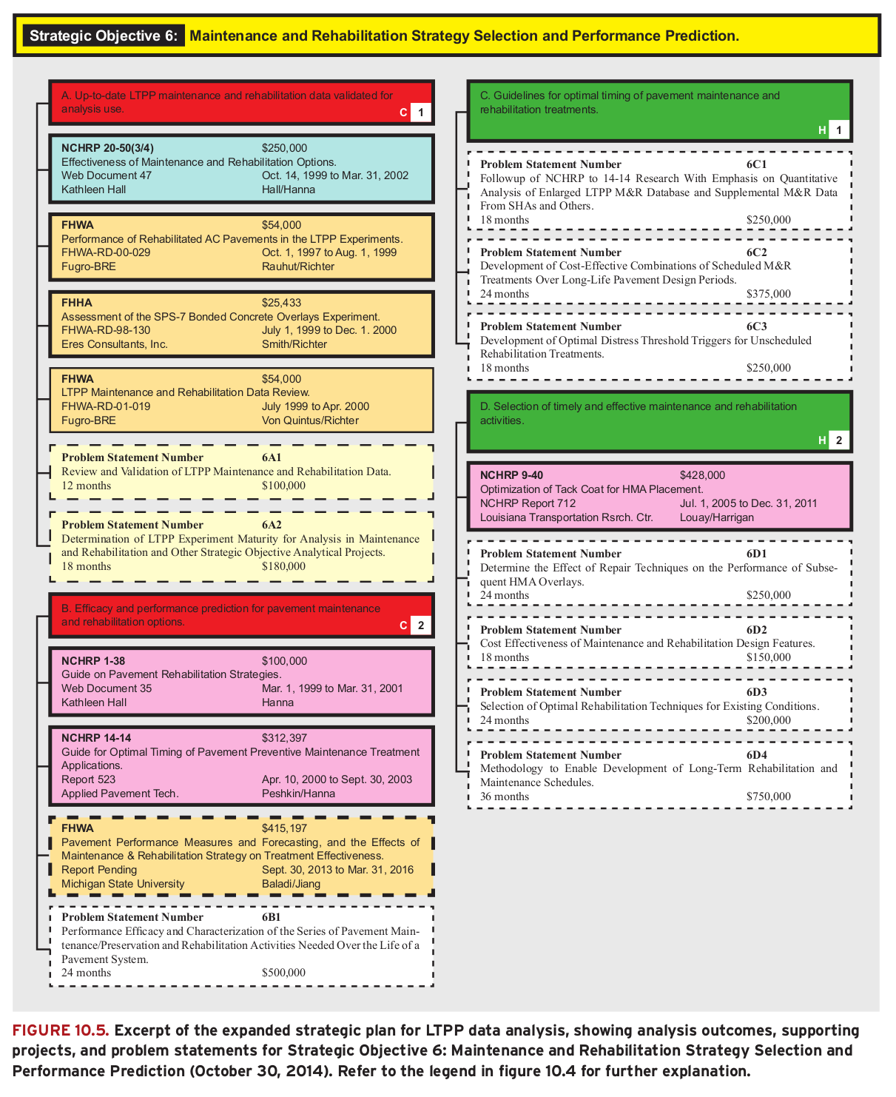

**Appendix B - Review Response Submitted to Pennoni (first page)**

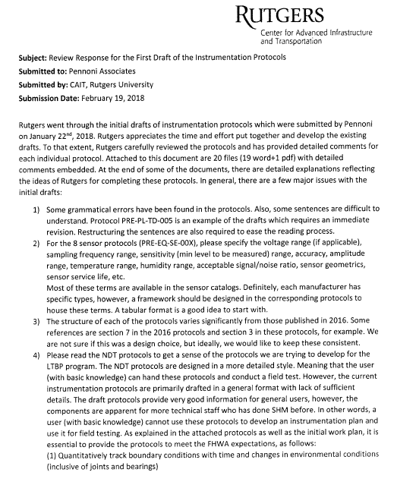

**Appendix C - Analyzed statistics for the data collection task- 1200 bridges (from the previous contract)**

**Appendix D - Review Response Submitted to Infratek**

